**MID - TERM III EXAMINATIONS, 2024**

**MIDDLE CLASS – NUMBERS**

**Name: ………………………………………………Stream: ………………..**

**1. Match shapes to their names.**

oval

square

zig – zag

cone

star

(10mks)

**2. Count and circle the correct number.**



**6 7 3**

**6 7 8**

**5 4 7**





**8 3 6**

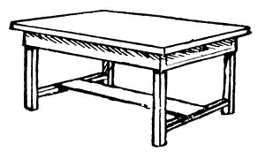

**5 8 1**

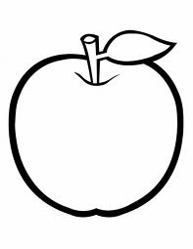

**3 4 2**

(10mks)

**3. Draw bead for the number.**

= 6 =4 =8

= 3 =0

(10mks)

**4. Shade the odd man out.**

________________________________

________________________________

________________________________

________________________________

_________________________________ (10mks)

**5. Write the number names.**

**2 ________________ 1 _____________**

**4 ________________ 3 _____________**

**0 ________________** (10mks)

**(zero, two, three, one, four)**

**6. Count and write.**

= ______ = _____ = ____

= _____ = _____

(10mks)

**7. Write numbers 0 – 10**

0 _____ ______ _____ _____ ______

_____ ______ ______ ______ ______

(10mks)

**8. Put me right.**

_______ _______

________ ________

________ (10mks)

**9. Count and write.**

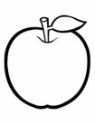

= _______

= _______

= _______

= _________

= ________

(10mks)

**10. Cross the given shape.**

(10mks)